

Practices for Secure Software Report

Table of Contents
Document Revision History 3
Client 3
Instructions 3
Developer 4
1. Algorithm Cipher 4
2. Certificate Generation 4
3. Deploy Cipher 5
4. Secure Communications 5
5. Secondary Testing 6
6. Functional Testing 7
7. Summary 7
8. Industry Standard Best Practices 7

Document Revision History

Version | Date | Author | Comments
1.0 | April 17, 2026 | Chuck Wagner | Initial Version

Client



Instructions

Submit this completed practices for secure software report. Replace the bracketed text with the relevant information. You must document your process for writing secure communications and refactoring code that complies with software security testing protocols.

- Respond to the steps outlined below and include your findings.
- Respond using your own words. You may also choose to include images or supporting materials. If you include them, make certain to insert them in all the relevant locations in the document.
- Refer to the Project Two Guidelines and Rubric for more detailed instructions about each section of the template.

Developer
Chuck Wagner

Algorithm Cipher

The SHA-256 cryptographic hash function was selected as the algorithm for checksum generation due to its strong security properties and widespread industry adoption. SHA-256 is part of the SHA-2 family and produces a 256-bit hash value, making it highly resistant to collisions and preimage attacks. Unlike older algorithms such as MD5 and SHA-1, which have known vulnerabilities, SHA-256 remains secure and is recommended for modern applications.
SHA-256 is a one-way hash function, meaning it cannot be reversed to retrieve the original input data. This makes it ideal for verifying data integrity. The algorithm operates on fixed-size blocks and uses complex mathematical transformations to produce a unique output for each input. Even a small change in the input results in a completely different hash value.
While SHA-256 itself does not use symmetric or asymmetric encryption keys, it can be used alongside secure communication protocols such as HTTPS, which rely on asymmetric cryptography for key exchange and symmetric encryption for data transmission. This layered approach enhances overall system security by combining data integrity verification with encrypted communication.
Historically, cryptographic algorithms have evolved to address weaknesses discovered in earlier implementations. SHA-256 represents a modern, secure standard that aligns with current best practices in software security.

Certificate Generation
Insert a screenshot below of the CER file.

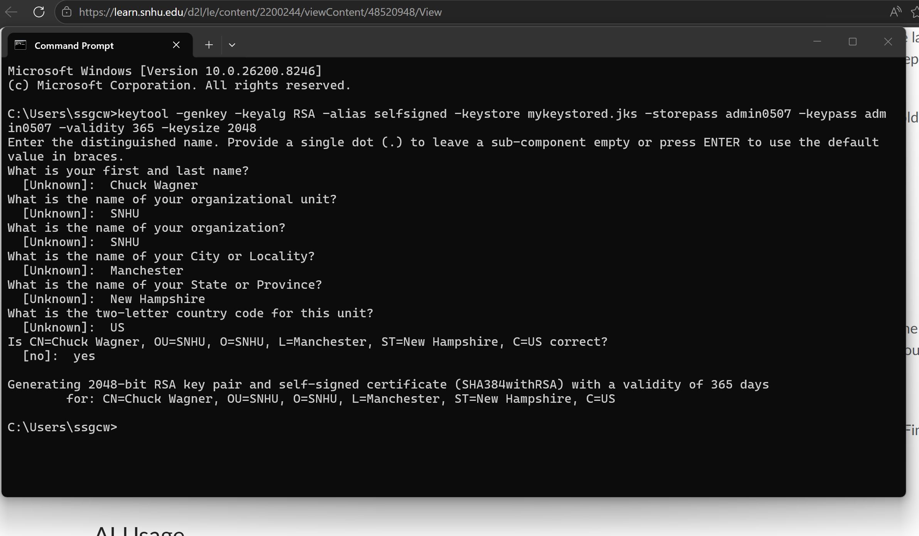

Deploy Cipher
Insert a screenshot below of the checksum verification.

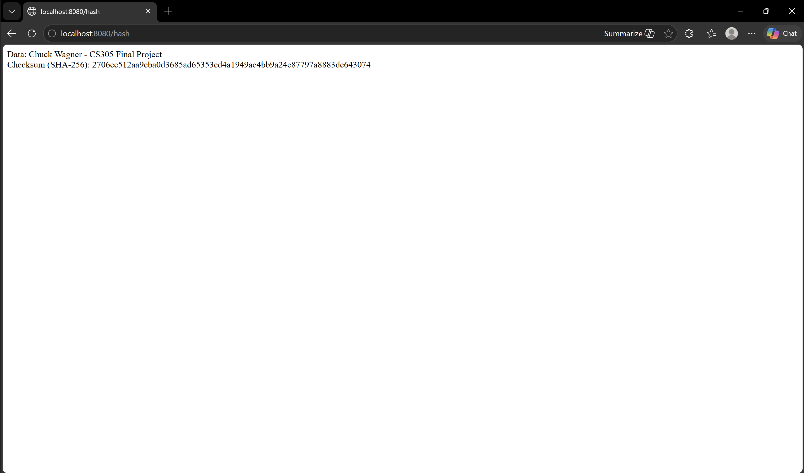

Secure Communications
Insert a screenshot below of the web browser that shows a secure webpage.

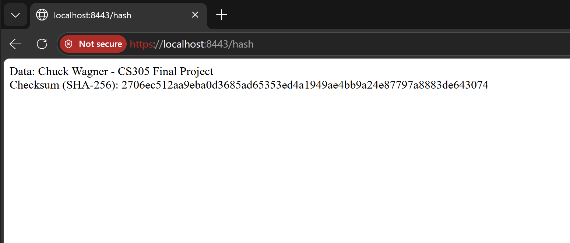

Secondary Testing
Insert screenshots below of the refactored code executed without errors and the dependency-check report.

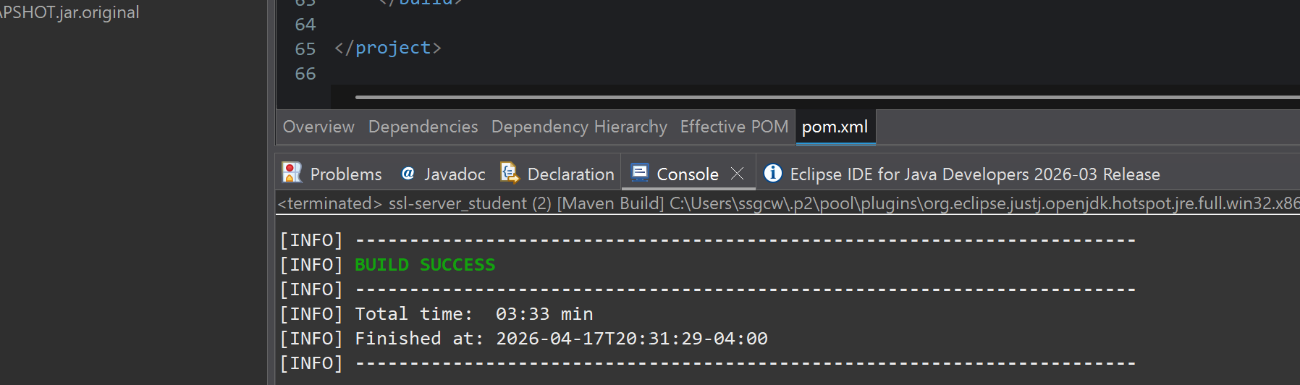

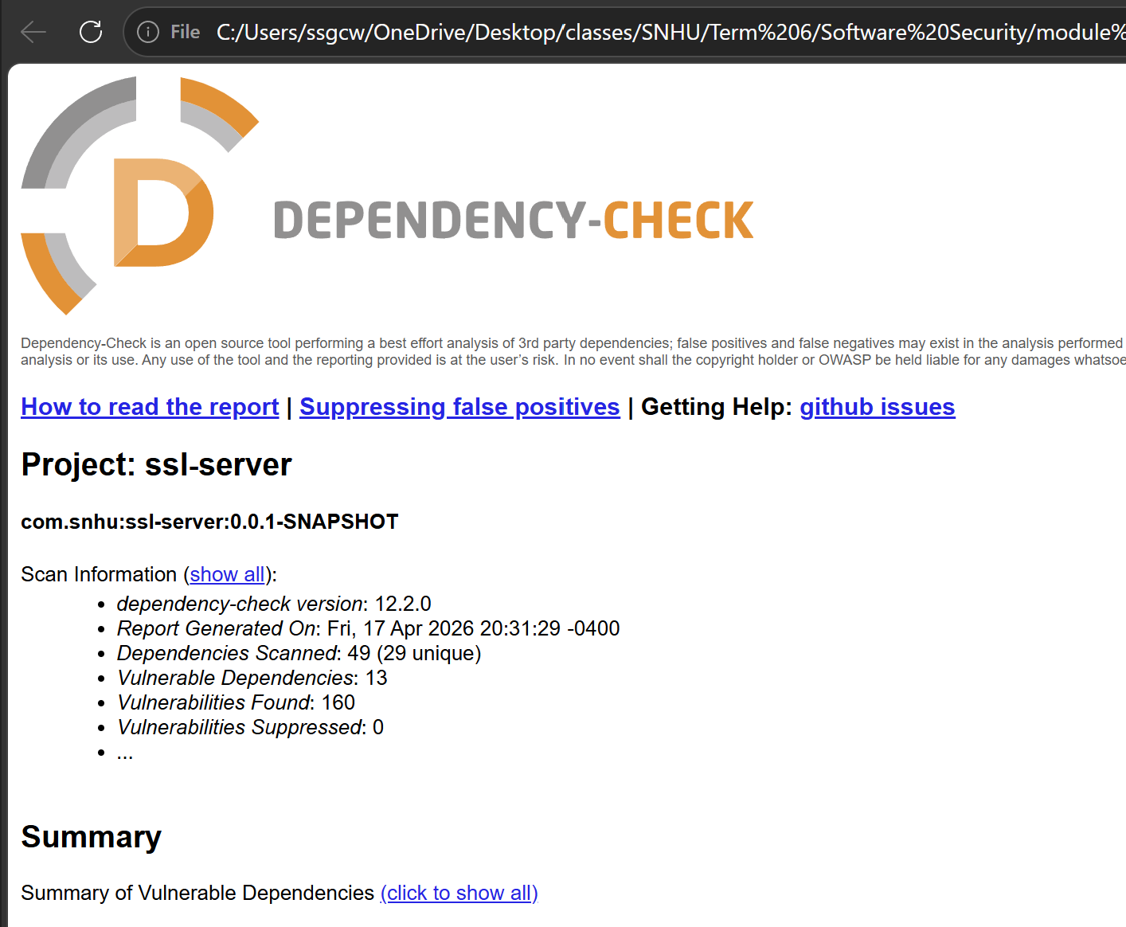

Functional Testing
Insert a screenshot below of the refactored code executed without errors.

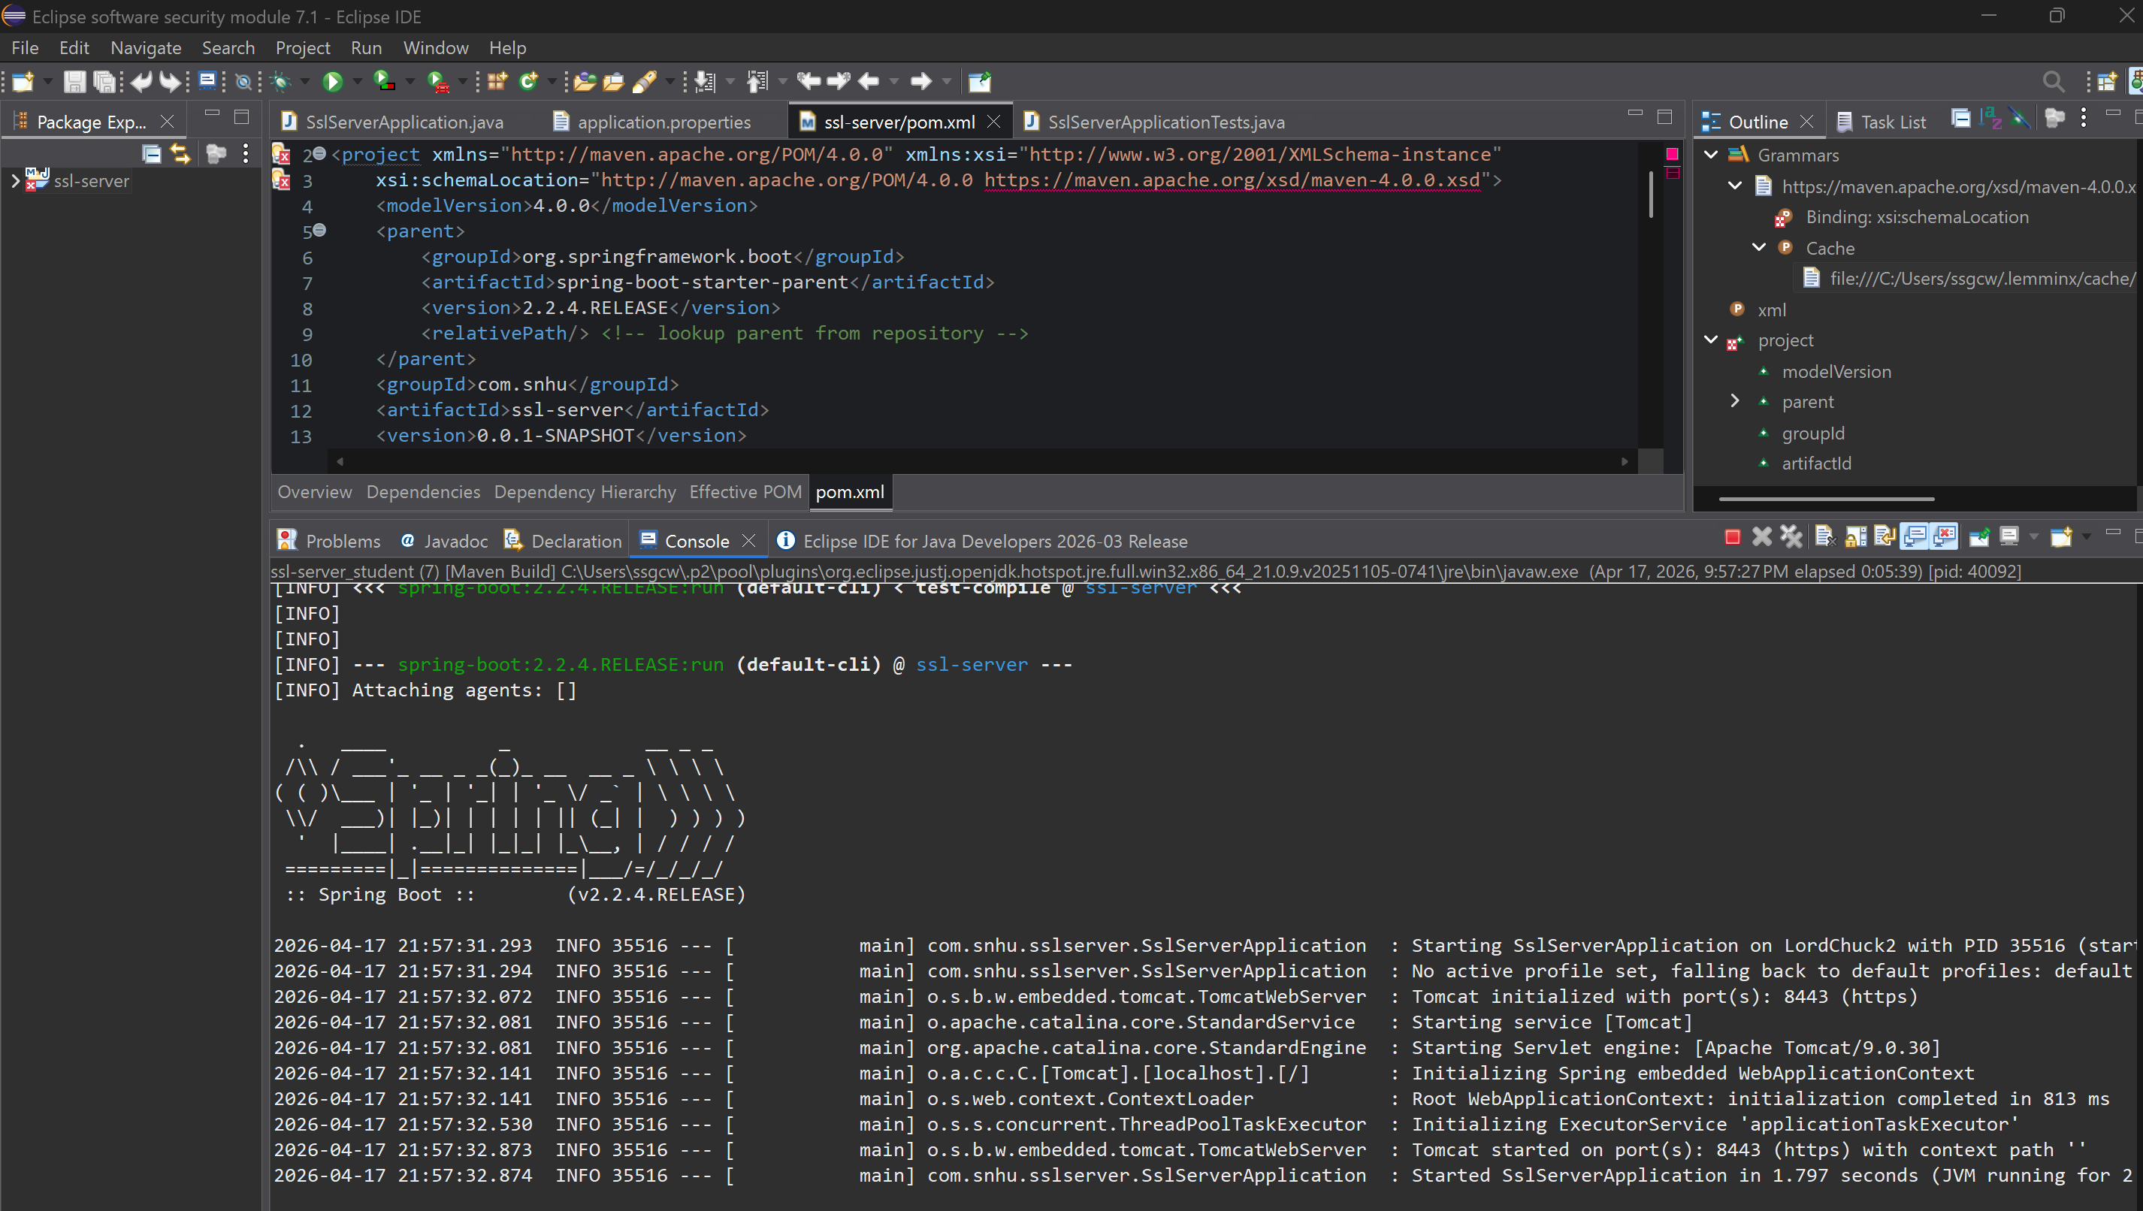

Summary

The application was successfully refactored to incorporate multiple layers of security. A checksum verification mechanism was implemented using the SHA-256 hashing algorithm to ensure data integrity. Secure communication was established by configuring the application to use HTTPS with a self-signed certificate, providing encrypted data transmission between the client and server.
In addition, a secondary static analysis was performed using the OWASP Dependency-Check tool to confirm that no new vulnerabilities were introduced during the refactoring process. Manual functional testing further verified that the application operates correctly and securely.
These enhancements align with the vulnerability assessment process by addressing data integrity, secure communication, and dependency validation, resulting in a more secure and reliable application.

Industry Standard Best Practices

Industry standard best practices for secure coding were applied throughout the refactoring process to improve the application’s security posture. The use of SHA-256 ensures strong data integrity verification, while the implementation of HTTPS provides encrypted communication to protect sensitive data during transmission.
Established cryptographic standards were followed by avoiding deprecated algorithms and using widely accepted secure alternatives. Additionally, the application was tested using automated tools such as OWASP Dependency-Check to identify potential vulnerabilities in third-party dependencies.
Applying these best practices helps maintain the security of the application over time and reduces the risk of exploitation. For organizations such as Global Rain and Artemis Financial, adhering to secure coding standards is critical to protecting client data and maintaining trust.

